# Application Description

1.This is the main interface. Client(customer or employee) need to select a store they want to go or work in.

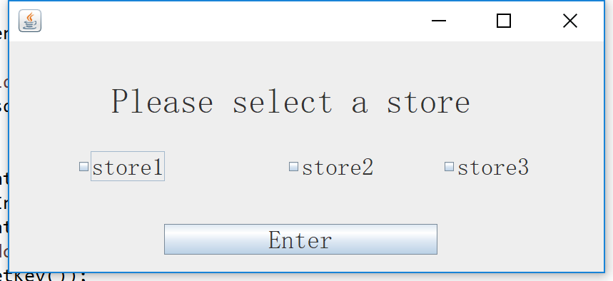

2. This is the log-in interface. Client need to select their role and employee should type in their ID and password to enter the system, customer need to type in their ID and gmail(which they register). Customer can register for a new account clicking on ‘sign up’. And on the left bottom, it shows the open-time of each store and it’s dynamic.

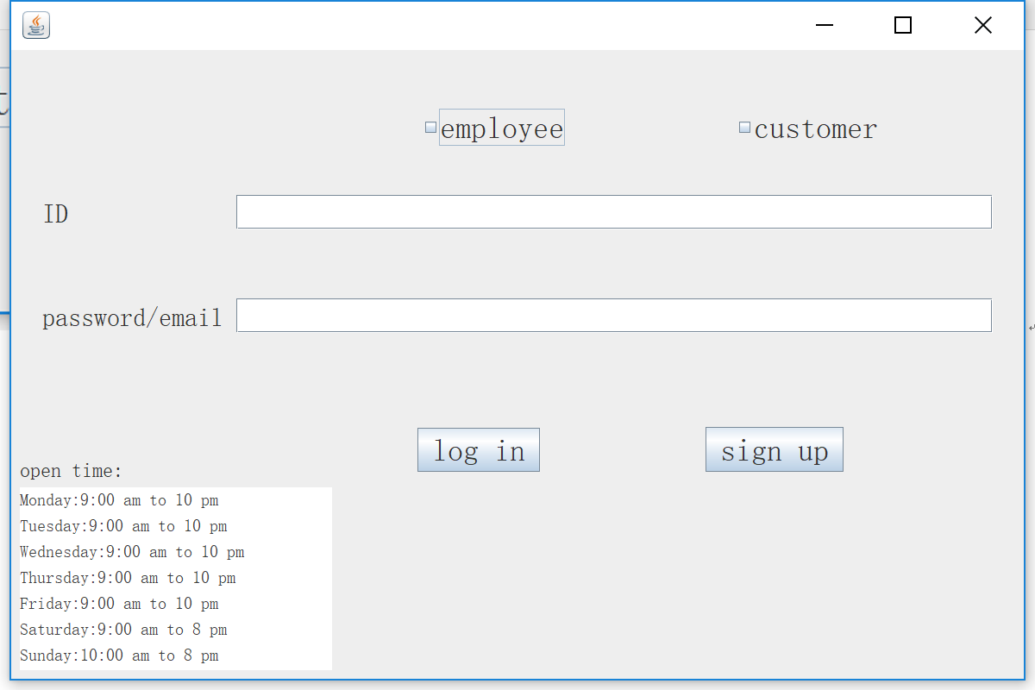

3.This is register-UI. Customer should type in their information and submit.

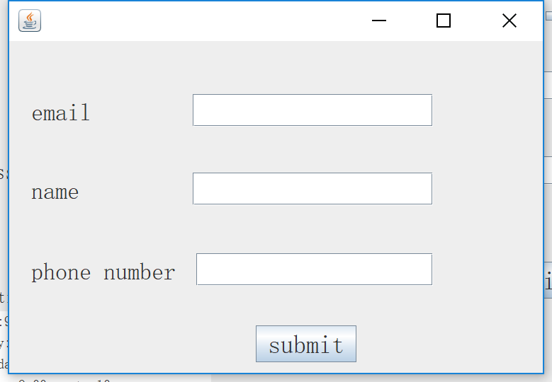

4.When a customer finish their registration, they will be assigned a new ID used for log-in, this ID is produced randomly and unique;

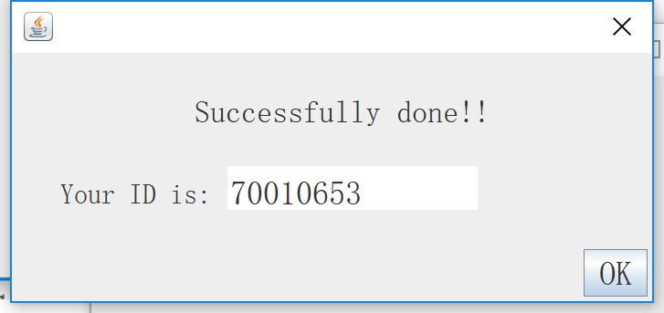

5.This is costumer-UI. They can edit their information and credit card info or check-out.

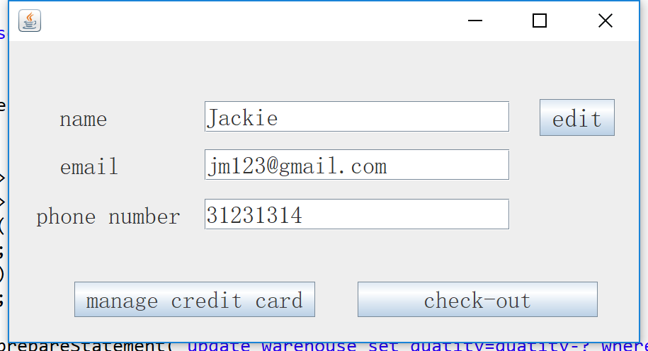

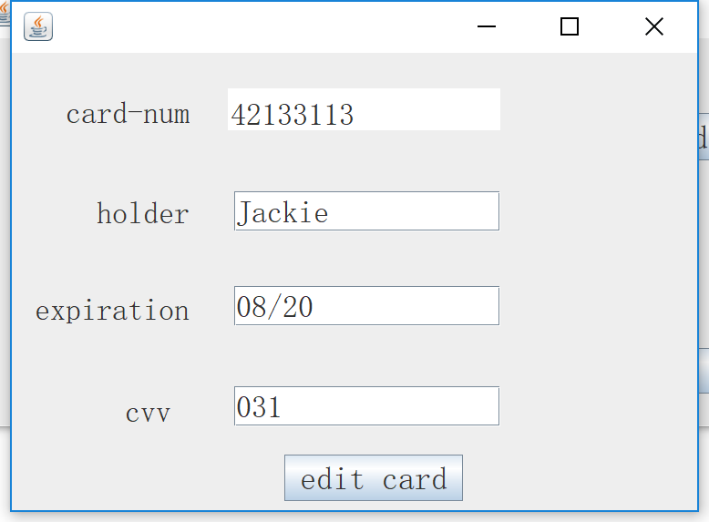

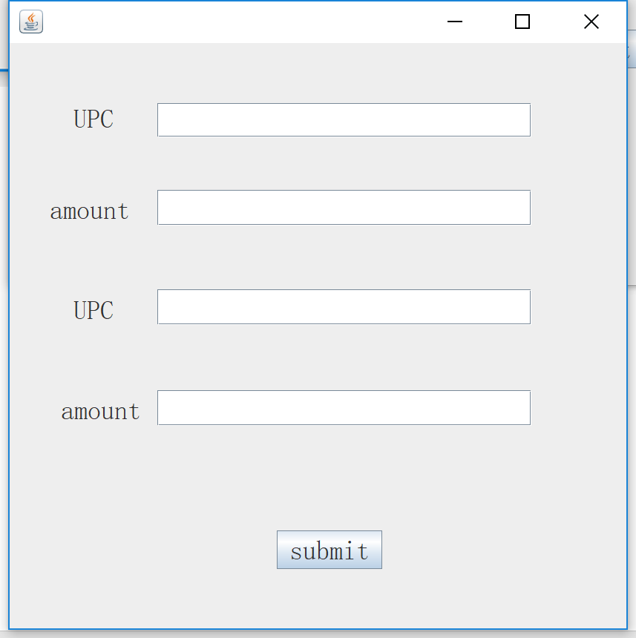

6.Customer need to type in UPC and amount of a product and submit. And this dialog shows afer submission success.

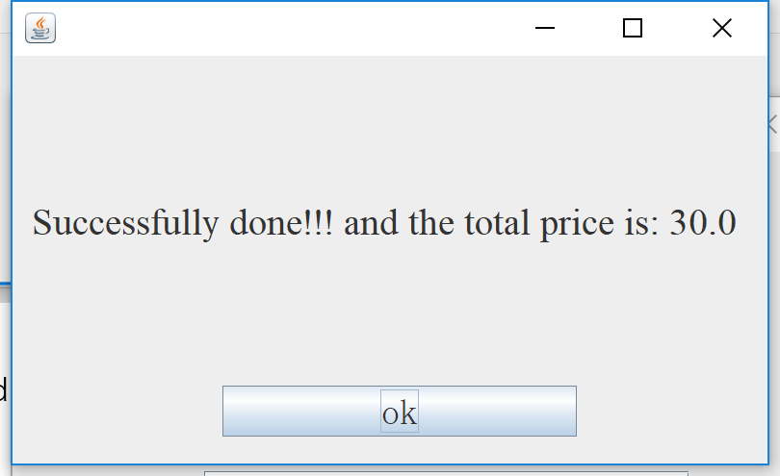

Else,

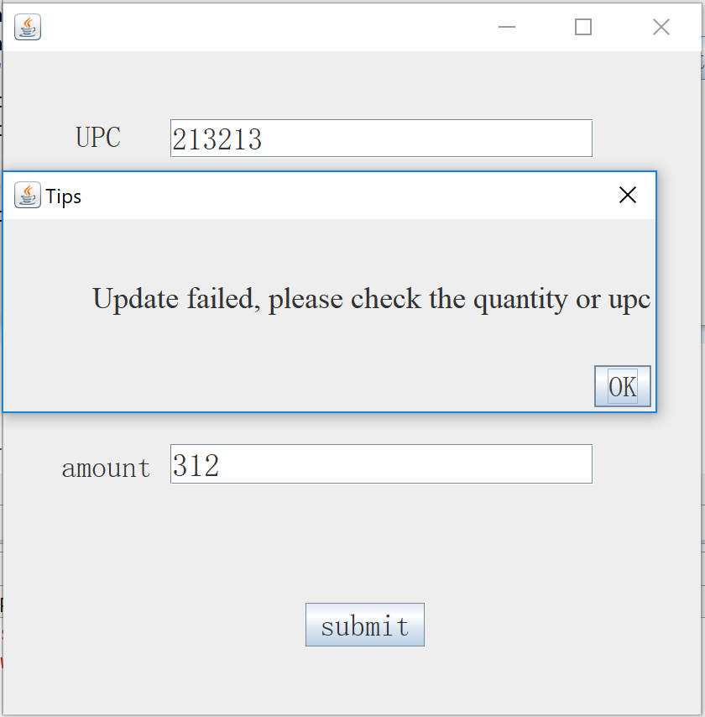

7.This employee-UI. They can check the quantity of product sorted by category in the specific warehouse they work in and update the stock.

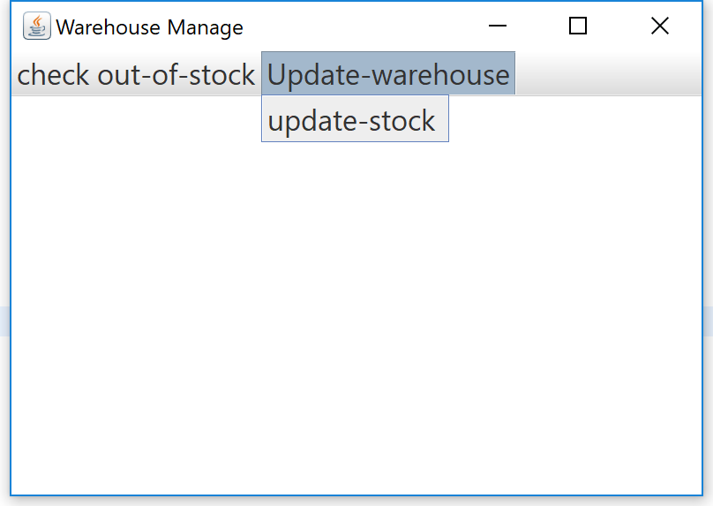

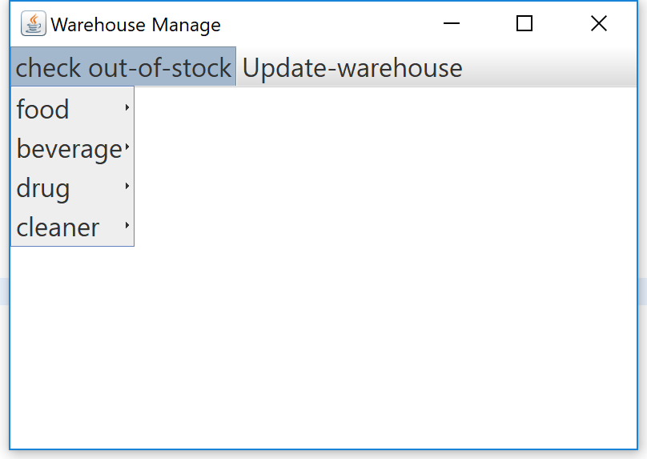

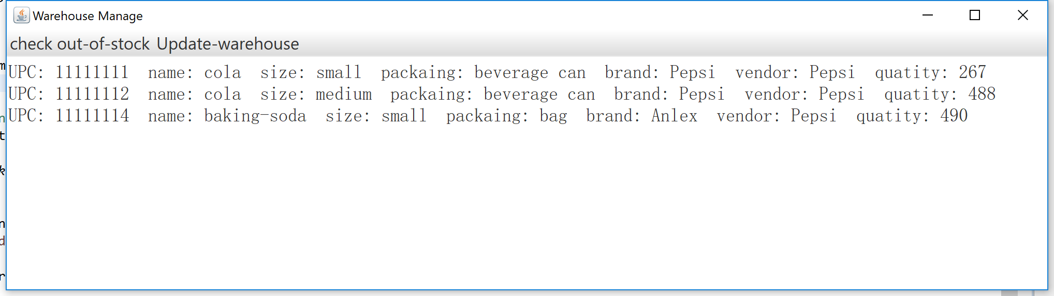

8.Employee can update quantity of product, they should type in UPC and amont. System wil check if the number they type-in exceed the capacity of warehouse.

